**Rocks Assignment Part 1**

**MARK**

**/26**

Name:

**Laboratory Report**

Task

You have a new job as a geologist and you have been given **2 rock samples** to analyse**.** These rocks are from a site of great importance relating to Aboriginal and Torres Strait Islander cultures.

It is your job as a scientist to:

1. Identify the types of rocks you have been given all of the skills you have learnt in class
2. Discover the historical importance of these rocks to Aboriginal and Torres Strait Islander cultures.

What You Need

Rock sample 1 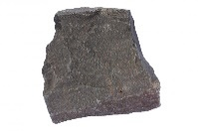 Grain size chart 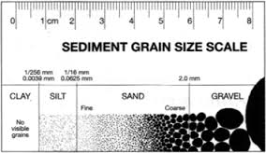

Rock sample 2 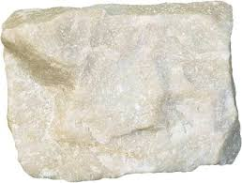 Hand Lens 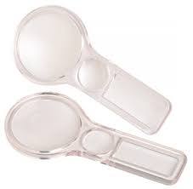

What to do

In pairs, spend 5 minutes looking at your rock samples, discuss what you can see

Ask yourself…

* + - * What does the rock look like?
      * Is it hard?
      * What Colour is the Rock?
      * Is it heavy/light to hold?
      * Can you see anything interesting on the rock?

Fill in the tables of different Rock Properties below.

* 1. **How it looks? (Draw a coloured diagram for each)** (6 marks)

|  |  |  |  |
| --- | --- | --- | --- |
|  | **Colour** | **Shape** | **Texture** |
| **Rock Sample 1** |  |  |  |
| **Rock Sample 2** |  |  |  |

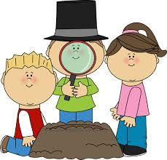

* 1. **How it looks – With the hand-lens?**

**(Draw a coloured diagram for each)** (6 marks)

|  |  |  |  |
| --- | --- | --- | --- |
|  | **Layers** | **Crystals** | **Grains** |
| **Rock Sample 1** |  |  |  |
| **Rock Sample 2** |  |  |  |

* 1. **How hard is the rock?**

Using the mineral samples of Calcite (Hardness of 3 on Mohs Scale) and Quartz (Hardness of 7 on Mohs Scale), find out how hard the rock is compared to these samples.

|  |  |  |  |  |  |  |  |  |  |  |
| --- | --- | --- | --- | --- | --- | --- | --- | --- | --- | --- |
|  |  |  |  | **Mohs Hardness Scale** | | |  |  |  |  |
|  |  | Soft |  | Medium | | |  |  | Hard |  |
| **Hardness** | 1 | 2 | 3 | 4 | 5 | 6 | 7 | 8 | 9 | 10 |
| **Mineral** | Talc | Gypsum | Calcite | Flourite | Apatite | Feldspar | Quartz | Topaz | Corundum | Diamond |

Method

A mineral **WILL** scratch another mineral with a **HIGHER** hardness number.

A mineral will **NOT** scratch another mineral with a **LOWER** hardness number.

Using this information, take the minerals Calcite and Quartz to **gently** scratch.

Write down in the table below if your rock samples are SCRATCHED or NOT SCRATCHED by the minerals.

Results (4 marks)

|  |  |  |
| --- | --- | --- |
|  | **Calcite (3)** | **Quartz (7)** |
| **Rock Sample 1** |  |  |
| **Rock Sample 2** |  |  |



*Think!*

Conclusion (2 marks)

From my results **Rock Sample 1** could have a rock hardness of and **Rock Sample 2** could have a rock hardness of .

* 1. **What are my Rock Samples called?**

*Think!*

Look at your results from your scientific observations, and using a process of elimination, identify what your Rock Samples 1 and 2 are called.

|  |  |  |  |
| --- | --- | --- | --- |
| **Rock Type** | **Colour** | **Grain Size** | **Hardness** |
| Image result for basalt***Basalt*** | Dark (Black) | Fine/Medium | Medium/Hard (6/7) |
| ***Conglomerate*** | Mixed (Different colours) | Mixed | Hard/Soft (4/3) |
| ***Gniess*** | Light and Dark Bands | Coarse | Hard (8) |
| ***Pumice*** | Light (Grey) | Fine | Soft (3) |
| ***Quartzite*** | Light (White, yellow, grey, pink) | Coarse | Hard (7) |

* 1. **Conclusion**  (8 marks)

What do your results tell you?

From my scientific results, I can conclude that **Rock Sample 1** is . This is because the Rock Sample is in colour, has grains and is on the Mohs Hardness scale.

I can conclude that **Rock Sample 2** is . This is because the Rock Sample is in colour, has grains and is on the Mohs Hardness scale.

**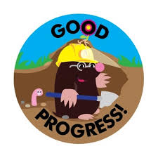****Rocks Assignment Part 2**

**MARK**

**/10**

Name:

**Location, Location, Location**

**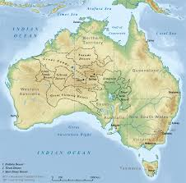***Well done geologists!!*

* 1. You have discovered two rock types, **Basalt (Igneous)** and **Quartzite (Metamorphic)**, you need to find the location of the rocks on your Geological Map.

Using the Aboriginal & Torres Strait Islander map, compare your maps and locate the same positions you have labelled your rocks on the new map.

How do I do this? (4 marks)

For Basalt (Igneous)

* + - * Locate the Map Key
      * Find the colour for Igneous Rocks
      * Look on the map and identify a location which you believe this rock could have come from
      * The location on the Geological Map is

Now go to the Indigenous map (<http://www.abc.net.au/indigenous/map/>) and find the location of rock sample 1.

The location on the Aboriginal & Torres Strait Islander map is

For Quartzite (Metamorphic)

* + - * Locate the Map Key
      * Find the colour for Metamorphic Rocks
      * Look on the map and identify a location which you believe this rock could have come from
      * The location on the Geological Map is

Now go to the Indigenous map (<http://www.abc.net.au/indigenous/map/>) and find the location of rock sample 2.

* + - * The location on the Aboriginal & Torres Strait Islander map is

* 1. **Research**

Investigate to find out what the basalt and quartzite rocks where used for by historical Aboriginal and Torres Strait Islanders. Write your draft copy below. (2 marks)

|  |  |
| --- | --- |
| Write your search words *(e.g. Basalt Indigenous tools, quartzite Indigenous Australian objects)* |  |
| Write down your URL’s which you used information from  *\*If you need help* |  |



**Draft Copy** (4 marks)

I believe the language tribe utilised the **basalt rocks** for tools because

I believe the language tribe utilised the **quartzite rocks** for tools because

* https://australianmuseum.net.au/explore-indigenous-australian-objects

*http://www.abc.net.au/news/science/2016-05-11/worlds-oldest-known-ground-edge-stone-axe-fragments-found/7401728*http://www.environment.nsw.gov.au/nswcultureheritage/StoneTools.htm

**Final Copy for presentation reading**

Name: